Lab 3 Scala

# Name : Devendra Johari

# Section : ML

# Roll No : 22

# University Roll No : 2015240

## Demonstrate print functions using Scala.

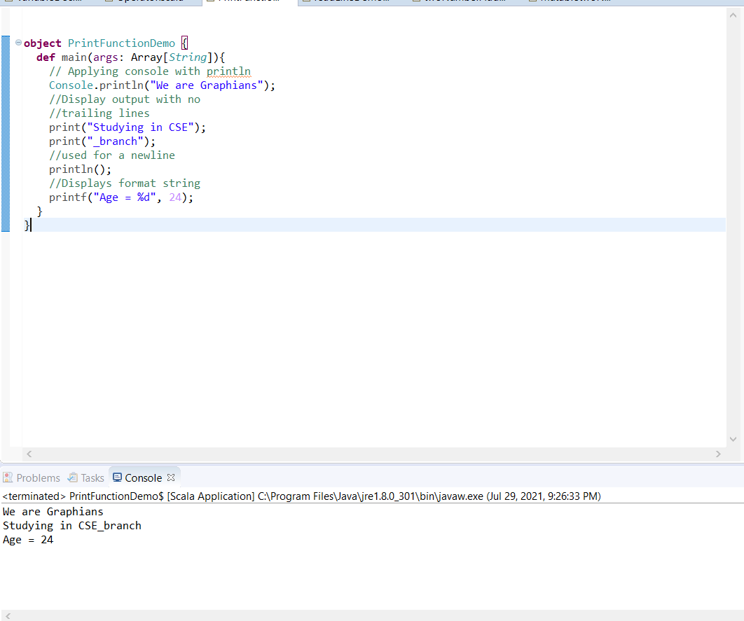

## Demonstrate readline function using Scala.

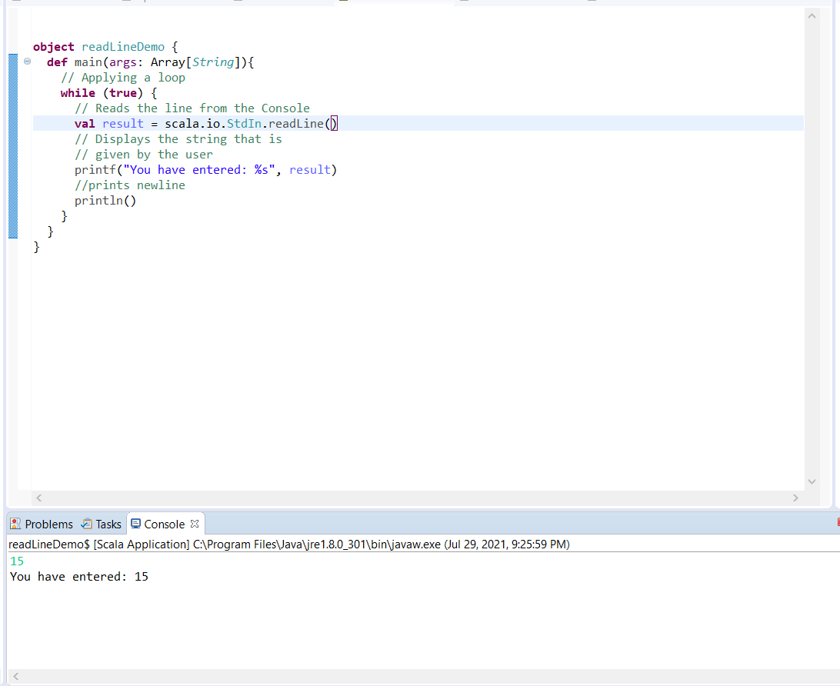

## Demonstrate any 20 keywords using Scala.

1. def
2. if
3. private
4. type
5. do
6. else
7. null
8. final
9. new
10. var
11. val
12. while
13. try
14. throw
15. false
16. catch
17. case
18. import
19. return
20. package
21. for
22. true

## 4. Write a function to add two numbers using mutable.

## 

## 5. Write a function to add two numbers using immutable values.

